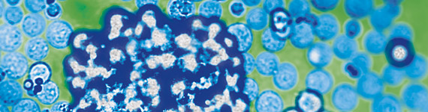

MACS刺激扩增体系

——MACSiBead原代细胞高效扩增工具

获得足够数量有功能的细胞是许多机理、功能研究、临床研究和应用的关键，由于体内样本来源和本身数量的限制，细胞体外扩增成为重要的获得大量细胞的途径。美天旎推出的MACSiBead及相关的扩增试剂盒可轻松偶联相应细胞表面分子的特异性抗体或配体，模拟体内细胞-细胞相互作用，有效活化相应细胞。除常见的细胞扩增试剂盒外，您还可以根据实验需要选择相应的抗体/配体/受体，结合美天旎MACSiBead磁珠，扩增特殊目的细胞。

* + - * 高效促进细胞活化增殖
      * 安全、对细胞无毒性
      * 与下游实验兼容
      * 细胞抑制功能研究的优化方案

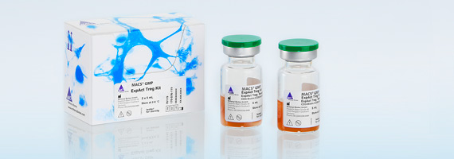

**Realgen-bio.com**

**MACSiBead™ Particles**

**原理：**

MACSiBead™直径为3.5 μm，表面偶联anti-biotin抗体，是一种专为不同类型原代细胞的活化、扩增和分化而设计的磁珠。与传统的可溶性或包被的抗体/配体刺激不同， MACSiBead™由于其与细胞大小相仿，可通过anti-biotin抗体将生物素化的抗体或配体负载到磁珠上，可高效促进细胞表面抗原交联，模拟体内的细胞-细胞相互作用的活化过程，从而诱导细胞的活化及扩增（图一）。

另外，MACSiBead™也可用于非目的细胞或蛋白的去除（与MACSiMAG连用），以及特定细胞抑制功能研究。

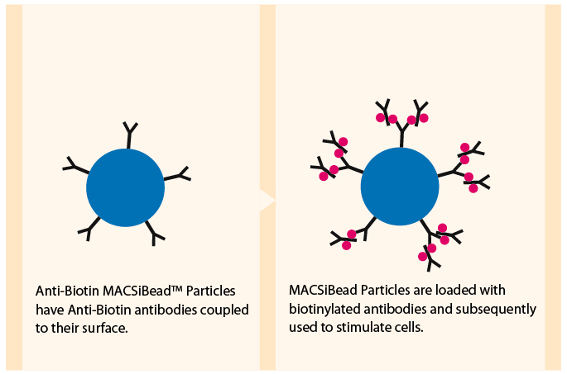

图1 MACSibead particles

* 活化速度快：1h
* 活化高效、充分
* 成分无毒，对细胞伤害小；
* 磁珠无自发荧光，与流式兼容
* 可通过MACSimag去除，操作简单

**MACSiMAG**

MACSiMAG™分选器专为去除细胞悬液中的MACSiBead™大磁珠而设计。一个MACSiMAG分选器一次可放置3个50 mL管或4个15 mL管，与MACSiMAG专用试管架配合可放置8个0.5 mL ~ 5 mL管。

* 操作简便，快捷；
* 去除效率高；
* 对后续实验无影响
* 应用广泛：
  + 与不同种类的MACSiBead结合，可用于细胞或蛋白、内毒素等成分的去除；
  + 不同细胞的活化扩增；
  + 特定细胞的抑制功能研究

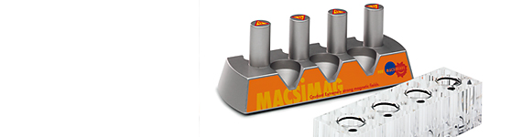

图2 MACSiMAG

相关促销信息请联系各区域代理商。

**细胞活化扩增研究**

**T cell expansion kit**

应用MACSiBead™可模拟体内T细胞的活化过程。偶联生物素抗体的MACSiBead™可负载 CD3和CD28抗体可模拟体内的抗原递呈细胞，引起T细胞表面的CD3和CD28分子等发生交联，快速活化。磁珠、抗体的浓度经过设计优化，使细胞的扩增效率达到最大。

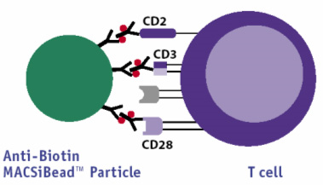

图3 Anti-Biotin MACSiBead Particle偶联特异性抗体与T细胞相互作用，引起细胞活化

**T细胞刺激扩增举例**

Stimulated sample Unstimulated control

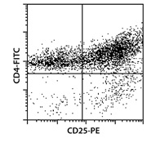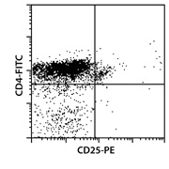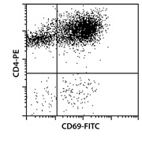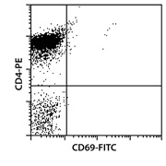

图4 Anti-Biotin MACSiBead Particles were loaded with CD2, CD3, and CD28 antibodies. T cells were isolated using the Pan T Cell Isolation Kit. Purified T cells were activated for 72 hours using one loaded Anti-Biotin MACSiBead Particle per two T cells. The negative control experiment was performed without adding MACSiBead Particles. Cells were fluorescently stained using CD4-FITC and CD25-PE or CD4-PE and CD69-FITC.

**Treg细胞扩增**

使用CD4+CD25+CD127dim/–或CD4+CD25+CD45RA+ Regulatory T Cell Isolation Kit分选的Treg细胞可通过Treg expansion kit进行特异性扩增，调整磁珠：细胞比例及细胞IL-2的浓度，可获得最大的扩增效率。扩增获得的细胞可用于细胞因子分析、基因表达分析和抑制功能研究等应用。

**NK expansion kit**

NK expansion kit基于生物素抗体偶联的MACSiBead，将生物素化的CD335 (NKp46) 和 CD2抗体负载到大磁珠上，可模拟体内的细胞-细胞相互作用过程，可高效活化和扩增静息的NK细胞。

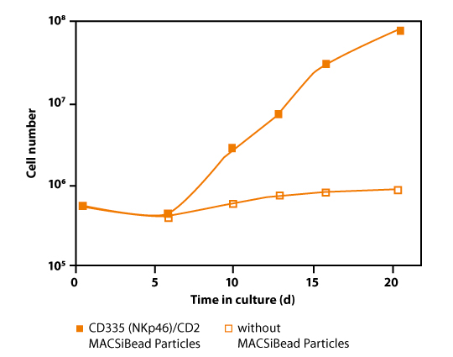

图5a Anti-Biotin MACSiBead Particles were loaded with CD335 (NKp46) and CD2 antibodies. NK cells were isolated using the NK Cell Isolation Kit, human, and expanded using one loaded Anti-Biotin MACSiBead Particle per two NK cells. NK cells were cultured in medium supplemented with 10% FCS and 500 IU/mL rIL-2 at an initial density of 106 NK cells per mL. Cells were expanded for 3 weeks. For comparison, NK cells were cultured in medium supplemented with 10% FCS and 500 IU/mL rIL-2 alone.

图5b Anti-Biotin MACSiBead Particles were loaded with CD335 (NKp46) and CD2 antibodies. NK cells were isolated using the NK Cell Isolation Kit, human, and expanded using one loaded Anti-Biotin MACSiBead Particle per two NK cells. NK cells were cultured in medium supplemented with 10% FCS and 500 IU/mL rIL-2 at an initial density of 106 NK cells per mL. Cells were expanded for 3 weeks. For comparison, NK cells were cultured in medium supplemented with 10% FCS and 500 IU/mL rIL-2 alone.

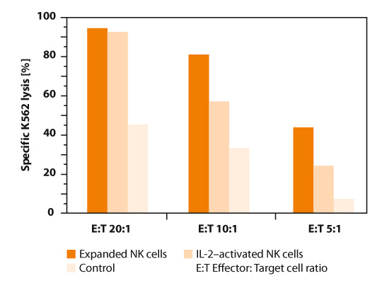

**细胞抑制功能研究**

很多细胞具有抑制其它细胞增殖的作用，体外将二者共孵育可研究其抑制功能。评价抑制性细胞的功能只有在效应性T细胞(Tresp)受到相应的刺激活化、扩增后才够准确。体内分离的原代细胞往往需要外加因子刺激才可活化扩增，以MACSibead为基础的抑制功能检测试剂盒为不同细胞的功能研究提供了更便捷、标准化的工具。

**Treg suppression Inspector**

**原理**

Treg suppression Inspector基于Anti-Biotin偶联的MACSiBead™ ，负载生物素化的CD2, CD3, and CD28抗体后，大磁珠可充分活化效应性T细胞扩增，Treg本身不会发生活化增殖。二者在共孵育过程中效应性细胞增殖水平减弱间接证明所获Treg细胞具有抑制功能。

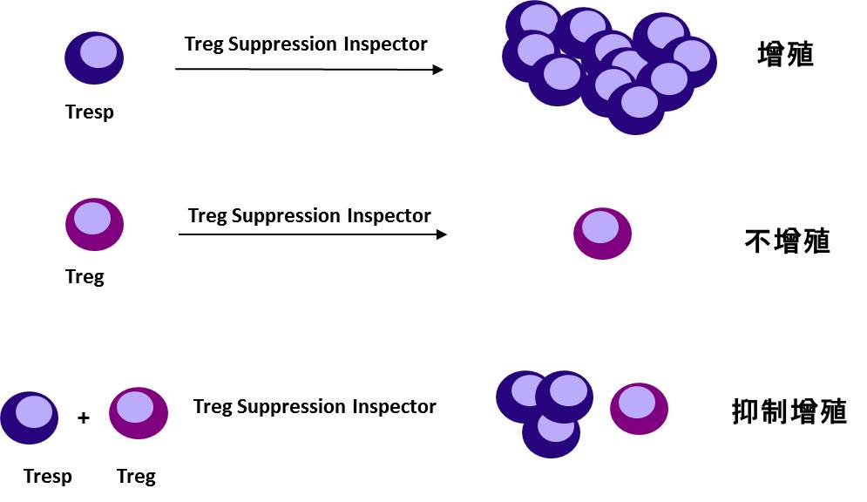

图6a Treg suppression Inspector能促进效应性细胞活化扩增，而对Treg细胞无活化作用

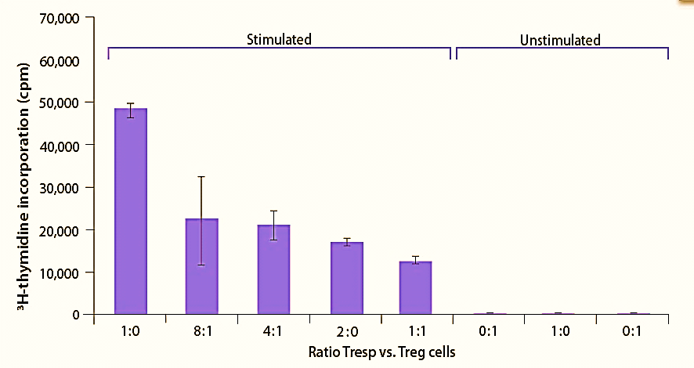

图6b CD4+CD25+ regulatory T cells, isolated with the CD4+CD25+ Regulatory T Cell Isolation Kit, were cocultured with CD4+CD25- responder T cells in different ratios. For T cell stimulation, the Treg Suppression Inspector was added to the culture. As controls, CD4+CD25+ Treg cells and CD4+CD25- responder T cells alone were cultured without any stimulus. Proliferation of T cells was determined by measuring 3H-thymidine incorporation.

**MSC suppression inspector**

MSC的免疫抑制功能是目前研究的一个热点。有研究表明骨髓来源的MSC可以抑制T细胞的增殖，提示其在免疫调节、自身免疫病研究、器官移植等应用中的作用。这种免疫抑制功能可通过MSC Suppression Inspector进行研究。 MSC Suppression Inspector包含了专为刺激T细胞活化而优化的试剂， 在这种多克隆刺激物的存在下，CD4+CD25– 或CD4+ 效应性T cell (Tresp)可被刺激活化而扩增，MSC细胞与之共孵育这种扩增将会被抑制。

**Gallery**

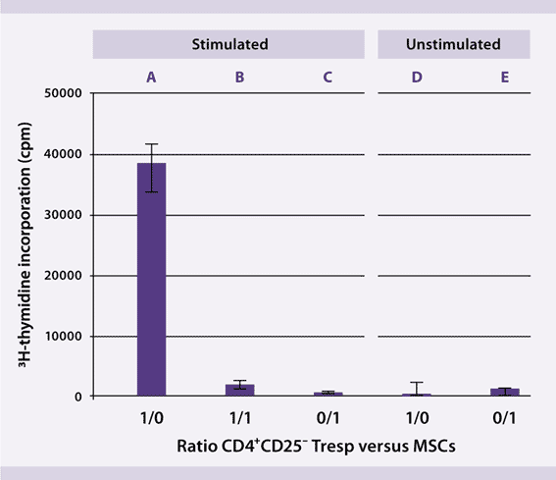

图7a MSCs were isolated from human bone marrow and expanded with MACS NH Expansion Medium. After two passages MSCs were co-cultured with CD4+CD25- responder T cells (Tresp) at different ratios. For T cell stimulation, the MSC Suppression Inspector was added to the culture. Proliferation of T cells was determined by 3H-thymidine incorporation. Tresp show high proliferation after stimulation with the MSC Suppression Inspector (A). When adding MSCs, Tresp proliferation is suppressed dramatically (B). Unstimulated Tresp show no proliferation (D). MSCs alone show little proliferation with or without stimulation (C and E).

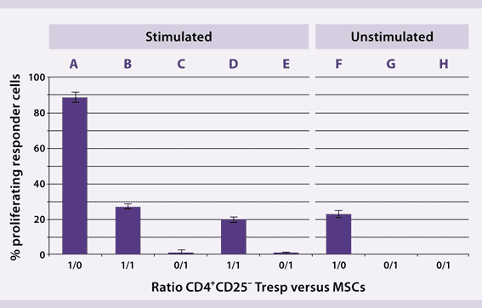

图7b MSCs were isolated from human bone marrow either by plastic adherence (PA-MSCs) or by isolation (CD271+ MSCs) using the CD271 MicroBead Kit (APC). Both PA-MSCs and CD271+ MSC were expanded with MACS NH Expansion Medium. After two passages MSCs were co-cultured with CFSE-labeled CD4+CD25– responder T cells (Tresp). For T cell stimulation, the MSC Suppression Inspector was added to the cultures. The percentage of proliferating Tresp was measured as CFSE dye dilution analyzed by flow cytometry using the MACSQuant® Analyzer.

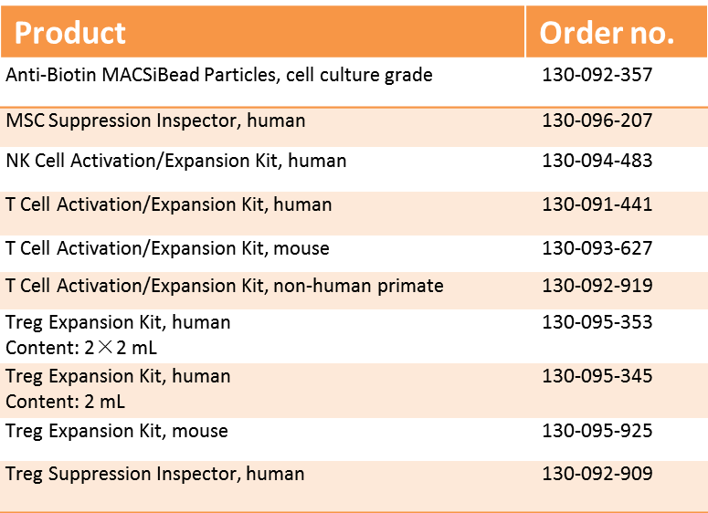

更多信息请登录：www.realgen-bio.com

**Related Items**